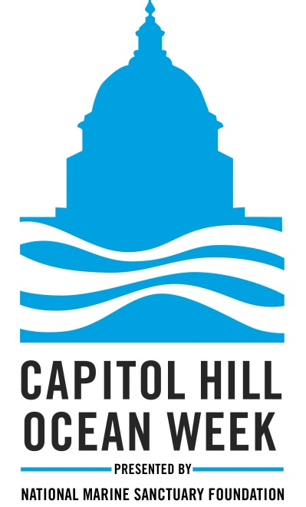
Capitol Hill Ocean Week® 2017
& NMSF Ocean Awards Gala™
Sponsorship Pledge Form

Company:
Please list company name as you would like it printed on event materials
Contact Name:
Title:
Mailing Address:
City: | State: | ZIP:
Phone: | Fax: | Email:

overall Event Sponsorships |  |  | Signature $50,000
Choose an overall event sponsorship level  Please see sponsor benefits package for a description of details of each level. |  |  | Presenting $30,000 | CoHost $20,000
 |  |  | Champion $15,000 | Partner $10,000
 |  |  | Friend $5,000 | Contributor $2,500
additional sponsorship opportunities | Purchased without overall event sponsorship |  | Purchased with any overall event sponsorship selected above
CHOW Booth Sponsor | $2,500 3 days |  | $1,000 3 days
 | $1,000 1 day
Networking Event Sponsor | $2,500 |  | $2,500
Bag Sponsor | $5,000 |  | $5,000
Refreshments Sponsor | $5,600 1 day |  | $3,000 per day  X days
 | $15,000 3 day
Happy Hour Sponsor | $10,000 |  | $10,000
Gala Reception Display | $2,000 |  | $2,000
Awards Gala Table Sponsor (10 seats) | $3,500
Individual Awards Gala tickets | $295  X tickets |  | Choose only if additional tickets are needed beyond what is included in overall sponsorship  $295 X tickets
TOTAL

For inclusion on the gala invitation, please return this form by March 17th.
FAX to 301-608-3044 • EMAIL to allison@marinesanctuary.org

Mail checks payable to National Marine Sanctuary Foundation to:
8601 Georgia Avenue, Suite 510 • Silver Spring, MD 20910
Payment is not due with the form.

NMSF is recognized as a 501(c)3 non-profit public charity #94-3370994.

For more information contact: Allison Alexander at (301) 608-3040 x303 or allison@marinesanctuary.org

